ANNUAL PROGRESS Report Template FOR PROJECTS
System Transformation Grant
January 2022

d the Multiplier combined

OVERVIEW
Country: | Click to enter text.
Name of project this grant is contributing to: | Click to enter text.
Grant ID (if applicable) | Click to enter text.
Grant agent: | Click to enter text.
Grant effectiveness/start date: | Click or tap to enter a date.
Grant amount: | Click to enter amount.
Time frame examined in this report (from: month, day, year, to: month, day, year): | Click to enter text.
Date of report submission: | Click or tap to enter a date.
PURPOSE AND INSTRUCTIONS
Purpose
This system transformation grant annual progress report is learning oriented and seeks to:
- Assess and report on the performance progress and achievements of the grant for this reporting period, to inform improvements in the implementation of the grant so as to ensure that its intended aims are fulfilled.
- Share lessons to improve the grant activities and priorities.
- Ensure accountability and transparency of the grant and its commitments.
Instructions
This template is to be completed by the grant agent, after consultation with the government and local education group. As per GPE’s grant policy, the grant agent completes an implementation progress report on a yearly basis. The first annual progress report must cover the first 12 months of implementation and must be submitted no later than three months after the first anniversary of the official grant effectiveness/start date. The second annual progress report must be submitted no later than three months after the second anniversary of the official grant effectiveness/start date. And so forth.
The full report package consists of the following deliverables:
- Completed template (present form, including relevant annexes)
- Results framework and variable part data
- Tangible outputs and knowledge products generated with system transformation grant support, or stories of impact
- Documentation of the explicit confirmation that variable part targets have been reached this reporting period
For cofinanced grants, note that some sections in this template are about the entire project cofinanced by GPE and other donor(s) and other sections are about the portion of the project that is financed by GPE’s system transformation grant. The term “project” is used in the former case and “grant” is used in the latter case.
Text should be concise and clear. You may add annexes if you wish to display only key text in the report. Overlapping contents may be referenced cross-sectionally to avoid repetitions. It is encouraged to think of the questions as an interdependent whole to build the project’s story line. Some questions are self-reflective in nature and will necessitate using judgment inferred from triangulated quantitative/qualitative information and logical explanations.
Present evidence and data disaggregated by varied subgroups (at a minimum by sex, and by any other groups as feasible). Include a gender and equity lens in the narratives, as much as feasible. Evidence and findings should be placed back into the national/subnational context of the country at the time of the review, for better unpacking the information.
The grant agent should submit the report through the GPE reporting portal. Please contact the grant operations officer for your country if you do not have credentials to access the portal. Following submission, grant agents may be contacted by the GPE Secretariat for additional information or clarification. The final completion report will be publicly disclosed after it is submitted by the grant agent and reviewed by the GPE Secretariat. Please reach out to your GPE Secretariat primary contact in case of questions.
LIST OF ACRONYMS
Please insert the list of acronyms used in this report, if any.
Click here to add acronyms.

1. IMPLEMENTATION PROGRESS
1.1 Overall project progress this reporting period
Indicate the overall level of progress this reporting period toward achieving the project’s objective(s), taking into consideration: the progress of the individual project components/objectives and variable part, level of financial absorption and management performance (that is, project and financial management, procurement, monitoring and evaluation (M&E) financial reporting requirements and any other compliance requirements). |  |  |  | Overall progress this reporting period: Select a rating.
To explain the progress rating above, please describe:
- Major accomplishments this reporting period.
- Which implementation challenges or delays the project experienced this reporting period; the reasons behind these issues; how (well) these have been mitigated thus far; and what remains to be done by whom and by when to address the challenges.
- Factors that led to any upgrade/downgrade in the progress rating above, compared with the previous reporting period (if any).
- Whether any progress was made in mitigating previous reporting periods’ challenges or delays (if any).
Click to enter text.
For projects with an overall rating of Moderately Unsatisfactory or below this reporting period:
Describe priority actions for the following reporting period to overcome constraints, build on achievements and partnerships, and use the lessons learned during the reporting period.
Click to enter text.
1.2 Project progress by component/objective
Provide in annex 2 information on the level of implementation progress for each project component/objective this reporting period:
- Progress ratings by component/objective
- Brief narrative on key activities undertaken and deliverables completed, by component/objective
1.3 Progress on the variable part (if any)
If applicable, describe:
- How well the variable part (VP) strategies have been and/or are on track to be implemented and whether targets have been and/or are on track to be reached within agreed timelines.
- How and when verification has been conducted for targets (expected to be) achieved during the reporting period.
In addition, please fill in the VP Reporting Template in annex 3. In case of questions, the Secretariat may contact you within 6 weeks after receipt of the template. You may also submit the results framework for the VP, if there is one.
Lastly, attach documentation of the explicit confirmation that VP targets have been reached to allow (partial) disbursement (for example, independent verification agent’s report, document for validation of results by the grant agent and/or the local education group.
Click here to enter text.
1.4 Progress on the Girls’ Education Accelerator funding (if any)
How successfully is the GEA alleviating gender-related barriers faced by girls? How well is it aligned with the system transformation grant interventions? Why or why not?
Please provide in annex 4 the data related to the GEA specific indicators included in the Results Framework.
Click here to enter text.
1.5 Lessons, innovative/promising practices
Indicate any emerging successful practices, innovative interventions in system-level transformative projects and capacity strengthening, or lessons, in relation to the implementation of the grant/project during this reporting period.
Click here to enter text.

1.6 Impact stories
This reporting period, have you identified any stories of impact of the project on beneficiaries that you would like to share with the GPE Secretariat Communications Team? If so, provide below or as an attachment. These stories will be featured on our communications materials and platforms, with attribution to the provider.
Click here to enter text.
1.7 Tangible outputs and knowledge products
Attach the tangible outputs and knowledge products (for example, evaluations, pilots, studies, etc.) generated through the support of the grant this reporting period. Also, attach any photos, videos, advocacy posters, and so on. as relevant that can be showcased in GPE stories or blogs.
2. FINANCIAL REPORTING AND GRANT MANAGEMENT
2.1 Financial reporting on GPE grant
Cumulative financial absorption rate: Provide a financial absorption rate based on cumulative expenditure expressed as a percentage of the approved budget to date and a rating. |  |  | Approved budget to date:
 |  |  | Cumulative expenditure: Click here to enter number.
 |  |  | Cumulative financial absorption rate: Click here to enter number.
 |  |  | Level of financial absorption: Select a rating.
If the financial absorption is not rated as On Track, please provide an explanation that identifies the main activities that have been delayed and their corresponding unspent amounts, as well as reasons for the delay and steps taken to ensure that expenditure absorption gets on track in the next reporting period.
Click here to enter text.
Budget variance analysis for the current reporting period:
(i) Total approved budget for the current reporting period | (ii) Total expenditure for the current reporting period |  | (iii) Explanation for underspending or overspending in excess of 10%
Click here to enter number. | Click here to enter number. |  | Click here to enter text.
2.2 Management performance
Provide a rating to indicate the performance of the grant during implementation in terms of its management this reporting period. This includes financial, procurement, social/environmental safeguards, M&E, implementation arrangements, and other fiduciary management or compliance duties. |  |  | Level of management performance: Select a rating.
Explain how these management arrangements/duties have affected, positively or negatively, the implementation of the grant and its progress toward achieving results/outcomes. Note any management-related issues or shortcomings during the period under review and how these have been/are being remediated. Why or why not?
Click here to enter text.
2.3 Revisions to the grant
This reporting period:  This period, have there been any revisions to the grant other than those submitted to the GPE Board or Secretariat for their approval? |  | In the next twelve months:  How likely is it that the government and the grant agent will submit a request for revision to the GPE Board or Secretariat in the next twelve months for their approval?
Yes/No. |  | Select from the list.
If yes, please describe them. |  | If Moderately Likely or above, please explain.
Click here to enter text. |  | Click here to enter text.

3. MONITORING DATA
3.1 Results framework indicator data
Provide the complete project’s results framework in a separate annex or as an attachment. The results framework should include the following:
- Milestone, end-target, and baseline indicator values, by objective and component/subcomponent
- Revised target values (if the original target value(s) were formally revised due to restructuring or changes during implementation)
- Status on the achievement against target values for the current year
- Reasons for any underachievement//overachievement of indicators this reporting period
3.2 Global numbers data
Provide in annex 5 the data related to GPE’s three global numbers for this reporting period:
- Textbooks purchased and distributed
- Teachers trained
- Classrooms built or rehabilitated
3.3 Cumulative beneficiary children data
Provide in annex 6 the data related to the cumulative number of children who directly participated in project activities, received project-supported incentives or services, or benefited from project interventions so far. If such data are not available, please explain the reasons why in the comment section in annex 6.
Also provide in the annex the relevant disaggregated values by subgroups at a minimum by sex. If appropriate and available, provide disaggregated values by varied subgroups (children with a disability, refugee children, internally displaced children, out-of-school children and children from marginalized ethno-cultural/linguistic minorities) and by education level. Please provide the number or proportion of girls of varied subgroups in the relevant comment section, if available.

Annex 1: Decision Trees for Overall Progress Rating and Component/Objective-Level Progress Ratings 1. Overall progress rating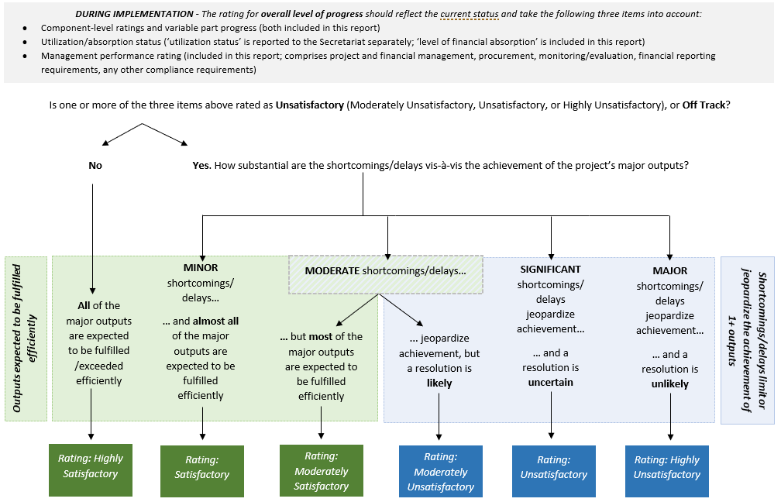
2. Component/objective-level progress ratings
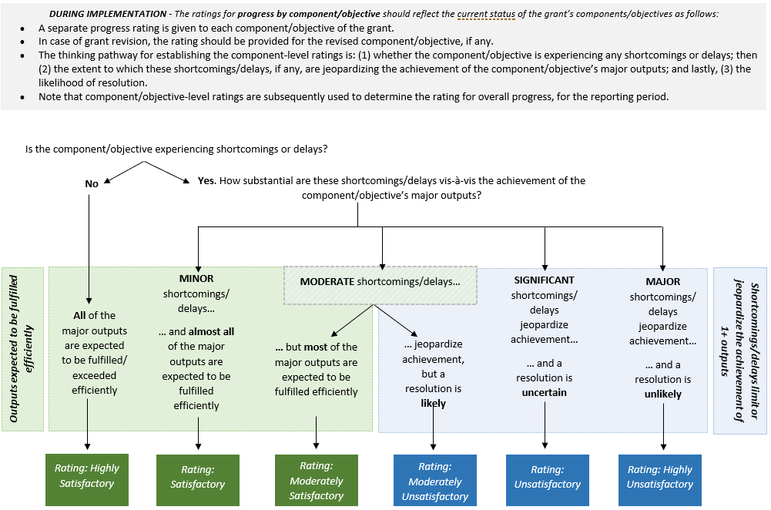

Annex 2: Project Implementation Progress, by Component/Objective
Implementation of the components/objectives of the project this reporting period
Select a rating to assess the level of implementation progress for each of the project’s components/objectives, in implementing the scheduled activities and fulfilling the project’s planned outputs this reporting period. Also briefly describe the key activities undertaken and deliverables completed.
Component/objective | Financed by Girls Education Accelerator? | Level of progress this reporting period | Brief description of the major activities undertaken and the relative level of success in fulfilling the project outputs and outcomes planned for this reporting period
Name of component/objective 1:  Click here to enter text. | ☐ | Select a rating. | Click here to enter text.
Name of component/objective 2:  Click here to enter text. | ☐ | Select a rating. | Click here to enter text.
Name of component/objective 3:  Click here to enter text. | ☐ | Select a rating. | Click here to enter text.
Name of component/objective 4:  Click here to enter text. | ☐ | Select a rating. | Click here to enter text.
(Add or remove components/objectives as needed.)
Annex 3: Variable Part Reporting Template (During Implementation)
Reporting period: from [Month/Year] to [Month/Year]
Indicator | Baseline |  | Target for reporting period | Achievement for reporting period | Disbursement for the reporting period |  | Cumulative disbursement |  | Evidence of achievements* (for example, independent verification report) and request for payout  * please note such evidence in this table and attach relevant documents
 |  |  |  |  | Actual amount disbursed  (in US$/€) | Proportion (%) of actual amount disbursed to the planned allocation for the reporting period | Cumulative amount disbursed  (in US$/€) | Proportion (%) of cumulative amount disbursed to the total allocation for the given variable part indicator
Select a dimension. Level of progress this reporting period: Select a rating.
1)…
2)…
3)…
4)…
Select a dimension. Level of progress this reporting period: Select a rating.
1)…
2)…
3)…
4)…
(Add or remove rows as needed.)

Annex 4: GEA Indicators Reporting Template
GEA Core indicators | Baseline | Results for this reporting period |  | % GPE contribution (optional for cofinanced grants) | Comments
 |  | Target | Actual
Indicator name Click here to enter text.
Date
Indicator name Click here to enter text.
Date
Indicator name Click here to enter text.
Date
(Add or remove indicator rows as needed.)

Annex 5: Global Numbers Reporting Template
General Instructions:
1) Starting from FY2021, only the actual global numbers achieved during a reporting period are required; no annual targets will be requested onward.
2) If the implementation grant does not include any or all global number(s), insert “not applicable” in the appropriate text box(es).
3) If an indicator is measured as a percentage, please provide the numeric values that were used to calculate the percentage. If these numbers are not available, please provide the percentage and make a note of it in the comments box.
GPE’s Definitions:
Textbooks purchased and distributed. This indicator tracks the number of school textbooks that were purchased and distributed through GPE’s implementation grants during a reporting period. “Textbooks” are books designed for instructing pupils in specific subject areas, including books described as “learning material.” They exclude books in school libraries as well as novels and books for use by teachers (such as curriculum guides, syllabi and teacher guides/kits). In cases where books are designated both as books for use by teachers and as books designed for instructing pupils, the books will be considered textbooks for the purpose of this indicator. The data refer to textbooks that have been “distributed” to schools and have either been distributed to pupils on loan or kept in schools for use in the classroom. The data on textbooks can include textbooks in stock but not currently in use by pupils.
Teachers trained. This indicator tracks the number of teachers who received and completed formal training, according to national standards through GPE’s implementation grants during the reporting period. “Teachers” comprise professional teaching/instructional personnel who are directly involved in teaching students. They include classroom teachers, special education teachers and other teachers who work with students as a class in a classroom, in small groups in a resource room or in one-to-one teaching inside or outside a regular classroom. Teaching/instructional staff excludes nonprofessional personnel who support teachers in providing instruction to students, such as teachers’ aides and other paraprofessional personnel. “Training” refers to formal teacher training (pre- or in-service) designed to equip teachers with the knowledge, attitude, behavior and skills required for teaching at the relevant level and perform their tasks effectively.
Classrooms built or rehabilitated. This indicator tracks the number of classrooms that were built and/or rehabilitated through GPE’s implementation grants during the reporting period. In the context of this indicator, “classrooms” comprise rooms in which teaching and learning activities can take place. They are semipermanent or permanent physical structures and may or may not be located in a school. The term “rehabilitated” may be interpreted differently in different contexts and may be subject to different standards. Therefore, judgment will be exercised to ascertain whether a rehabilitated structure (class, school building and so on) is in accordance with national or other standards that are acceptable and to the satisfaction of the implementing entity. In general, this term means that the structure (class, building and so on) has been renovated, either fully or partially, implying that the structure is brought up to code.
Note: For cofinanced grants, please provide the proportion that can be attributed to GPE grant. For example, if the grant’s financial contribution accounts for 50 percent of a teacher training activity, the proportion that can be attributed to GPE grant for the number of teachers trained through that activity would be 50%. If the unit of analysis in the indicator is the number of schools and not classrooms, please enter an estimated number of classrooms and provide an explanation in the comments box.

GPE indicators | Indicator name(s) as in the program document and application form | ACTUAL number achieved (during this reporting period)  • Please report the status in numbers, not in percentages or ratios.  * For a cofinanced project, please provide the number for the entire project. The GPE Secretariat will prorate it in accordance with the proportion attributed to this grant. | % attributed to this grant (for cofinanced grants) | Comments
Textbooks purchased and distributed | 1)…
 | 2)…
 | 3)…
Teachers trained | 1)…
 | 2)…
 | 3)…
Classrooms built or rehabilitated | 1)…
 | 2)…
 | 3)…

(Add or remove indicator rows as needed.)

Annex 6: Cumulative Beneficiary Children Reporting Template
Cumulative data on beneficiary children/other students
Provide the cumulative number of children of pre-primary, primary and secondary school age (both in school and out of school) and other students (adolescents beyond secondary school age and adult learners participating in basic education programs), who directly participated in project activities, received project-supported incentives or services, or benefited from project interventions so far. Also provide relevant disaggregated values by sex (applicable to all grants). If appropriate and available, provide disaggregated values by varied subgroups and by education level. Reporting beneficiary data cumulatively means counting all beneficiaries as a running total, adding up all beneficiaries since the start of the grant. Data on beneficiaries are to be collected using the methods and tools proper to each project. It is understood that some disaggregated data will only be collected if a project expressly targets specific subgroups through their interventions and uses their own methods for counting beneficiary children/other students. Please provide the number or proportion of girls of varied subgroups in the comment section below, if available.

NOTE:
For cofinanced grants, please provide the numbers for the entire program and indicate the proportion that can be attributed to GPE grant. For example, if the grant’s financial contribution accounts for 40 percent of the program that is cofinanced by GPE and other donors, enter 40% in the “% attributed to this grant.
 | Pre-primary (optional) | Primary (optional) | Secondary (optional) | Other  (optional) | Total | % attributed to this grant
Number of children/other students who directly benefited from the project over the entire duration of the project: | Enter number. | Enter number. | Enter number. | Enter number. | Enter number. | Enter number.
Of which, female: | Enter number. | Enter number. | Enter number. | Enter number. | Enter number. | Enter number.
Of which, children/other students with a disability (optional): | Enter number. | Enter number. | Enter number. | Enter number. | Enter number. | Enter number.
Of which, refugee children/other students (optional): | Enter number. | Enter number. | Enter number. | Enter number. | Enter number. | Enter number.
Of which, internally displaced children/other students (optional): | Enter number. | Enter number. | Enter number. | Enter number. | Enter number. | Enter number.
Of which, out-of-school children (optional): | Enter number. | Enter number. | Enter number. | Enter number. | Enter number. | Enter number.
Of which, children/other students from marginalized ethno-cultural/ linguistic minorities: specify which ones (optional): | Enter number. | Enter number. | Enter number. | Enter number. | Enter number. | Enter number.
Provide any comments on beneficiary children/students, if needed. This could include, for example, the definition employed by the project for a particular subgroup (including a more granular description of these subgroups), the approach/tool used to calculate the number of beneficiaries overall or by subgroup, any limitation of the approach/tool employed for this calculation and reasons why data on beneficiary children/students are unavailable.
Click here to enter text.

NOTES

“Effectiveness” (start) date is considered as the date when the grant implementation has effectively started, marked by the occurrence of an event defined in the grant application.
15 months at the latest after the official start date.
See in Annex 1 a decision tree to help determine an overall rating for implementation progress. The scale is as follows: Highly Unsatisfactory – The project has major shortcomings or delays that limit or jeopardize the achievement of one or more outputs and a resolution is unlikely. Unsatisfactory – The project has significant shortcomings or delays that limit or jeopardize the achievement of one or more outputs and a resolution is uncertain. Moderately Unsatisfactory – The project has moderate shortcomings or delays that limit or jeopardize the achievement of one or more outputs, but a resolution is likely. Moderately Satisfactory – The project is expected to achieve most of its major outputs efficiently with moderate shortcomings or delays. Satisfactory – The project is expected to achieve almost all of its major outputs efficiently with only minor shortcomings or delays. Highly Satisfactory – The project is expected to achieve or exceed all of the major outputs efficiently without significant shortcomings or delays.
Factors may include but are not limited to the following: project/grant management (management arrangements, roles and responsibilities), project/grant supervision (provided supervision during the implementation, including timely and proactive identification of issues and actions taken to address them), factors related to capacity (including institutional and organizational capacities, human resources–related capacities and other issues that impact capacity), financial management/fiduciary issues (including adequate procurement, financing, budgeting and financial management mechanisms in place following the grant agent’s policies and procedures), M&E (quality of M&E arrangements, including M&E design, implementation and utilization to inform project/grant management and decision making; issues related to data availability and so on), coordination, partnership and participatory processes (principal project partners, their roles and engagement; information on frequency and reasons for consultations with the local education group during the grant implementation), external factors, factors beyond the grant agent’s control and unforeseen circumstances (macroeconomic changes, conflict and instability, natural disasters, changes in government commitment and leadership, issues related to governance and politics, unforeseen technical and logistical difficulties, changes in project scope and so on), any other challenges and constraints, and factors contributing to problems or success in the grant implementation.
See in Annex 1 a decision tree to help determine component/objective-level implementation progress ratings.
Approved budget refers to the version of the budget that has been approved by the GPE Board (or relevant committee/Secretariat in their delegated authorities) or the revised version of the budget that has been duly approved in accordance with the provisions for revisions specified in the education sector program implementation grant policy.
Expenditure refers to the amount paid out by implementing partners or grant agents to third parties for services performed or goods delivered. It should not include commitments, which refer to the amount that implementing partners or grant agents have an obligation to pay based on signed contracts and following satisfactory contract performance.
Cumulative financial absorption rate can be calculated by using the following formula. Cumulative financial absorption rate (%) = (Cumulative expenditure)/(Approved budget to date) * 100
Off Track – Cumulative absorption rate is less than 75%. Slightly Behind – Cumulative absorption rate is greater than or equal to 75% but less than 90%. On Track – Cumulative absorption rate is greater than or equal to 90%.
Highly Unsatisfactory – Major shortcomings in grant performance management jeopardize the capacity to provide timely and reliable provision of information required to manage and monitor the implementation of the project and a resolution is unlikely. Unsatisfactory – Significant shortcomings in grant performance management jeopardize the capacity to provide timely and reliable provision of information required to manage and monitor the implementation of the project and a resolution is uncertain. Moderately Unsatisfactory – Moderate shortcomings in grant performance management jeopardize the capacity to provide timely and reliable provision of information to manage and monitor the implementation of the project, but a resolution is likely. Moderately Satisfactory – Moderate shortcomings in grant performance management exist but do not prevent the timely and reliable provision of information required to manage and monitor the implementation of the project. Satisfactory – Minor shortcomings in grant performance management exist but do not prevent the timely and reliable provision of information required to manage and monitor the implementation of the project. Highly Satisfactory – The grant performance management system efficiently and reliably provides timely information required to manage and monitor the implementation of the project. Appropriate internal controls are in place and function effectively.
Revisions to the project are regulated by the Policy on Education Sector Program Implementation Grants (https://www.globalpartnership.org/sites/default/files/document/file/2021-09-gpe-policy-education-sector-program-implementation-grants.pdf). The policy describes the approval process for different types of revisions. Mentioning a revision in the implementation report doesn’t exonerate from following due process.
Highly Unlikely – A request for revision is extremely unlikely to be submitted to the GPE Board or Secretariat for their approval in the next 12 months. Unlikely – A request for revision is unlikely to be submitted to the GPE Board or Secretariat for their approval in the next 12 months. Moderately Unlikely – A request for revision is somewhat unlikely to be submitted to the GPE Board or Secretariat for their approval in the next 12 months. Moderately Likely – A request for revision is somewhat likely to be submitted to the GPE Board or Secretariat for their approval in the next 12 months. Likely – A request for revision is likely to be submitted to the GPE Board or Secretariat for their approval in the next 12 months. Extremely Likely – A request for revision is extremely likely to be submitted to the GPE Board or Secretariat for their approval in the next 12 months.
See in Annex 1 a decision tree to help determine implementation progress ratings at the component/objective level. The scale is as follows: Highly Unsatisfactory – The component/objective has major shortcomings or delays that limit or jeopardize the achievement of one or more outputs and a resolution is unlikely. Unsatisfactory – The component/objective has significant shortcomings or delays that limit or jeopardize the achievement of one or more outputs and a resolution is uncertain. Moderately Unsatisfactory – The component/objective has moderate shortcomings or delays that limit or jeopardize the achievement of one or more outputs, but a resolution is likely. Moderately Satisfactory – The component/objective is expected to achieve most of its major outputs efficiently with moderate shortcomings or delays. Satisfactory – The component/objective is expected to achieve almost all of its major outputs efficiently with only minor shortcomings or delays. Highly Satisfactory – The component/objective is expected to achieve or exceed all of the major outputs efficiently without significant shortcomings or delays.
Widely accepted definitions of these subgroups are provided for reference only, as we acknowledge that descriptions and criteria for measuring subgroups are context-dependent: Female: School-age female children and adolescents, and other students. Children with a disability: School-age children with impairments, activity limitations and participation restrictions. Impairment is a problem in body function or structure; an activity limitation is a difficulty encountered by an individual in executing a task or action, while a participation restriction is a problem experienced by an individual in involvement in life situations. Refugee children: School-age children who have fled war, violence, conflict or persecution and have crossed an international border to find safety in another country. Internally displaced children: School-age children who have been forced or obliged to flee or to leave their homes or places of habitual residence, in particular as a result of or in order to avoid the effects of armed conflict, situations of generalized violence, violations of human rights or natural or human-made disasters, and who have not crossed an internationally recognized state border. Out-of-school children: School-age children who are not enrolled in or attending schools. Out-of-school children encompass both dropouts and children who have never attended school. This second group can either be late entrants or children who will never attend school. Children from marginalized ethno-cultural/linguistic minorities: School-age children from a group numerically inferior to the rest of the population of a state, in a nondominant position, whose members—being nationals of the state—possess linguistic characteristics differing from those of the rest of the population; from a group numerically inferior to the rest of the population of a state, in a nondominant position, whose members—being nationals of the state—possess ethnic characteristics differing from those of the rest of the population.
Other includes students beyond the school age of pre-primary through secondary that are not already included (out-of-school adolescents and adult learners participating in nonformal education).

